1) Started by Signing as a customer ---> Sign up as customer ---> ease up my using google account
while linking the account with the app , it crashes with a “Report Bug” Error , on Android version 6.0.1 , Device name Redmi note 3 running MiUi version 9.5.6. Screenshot appended below.

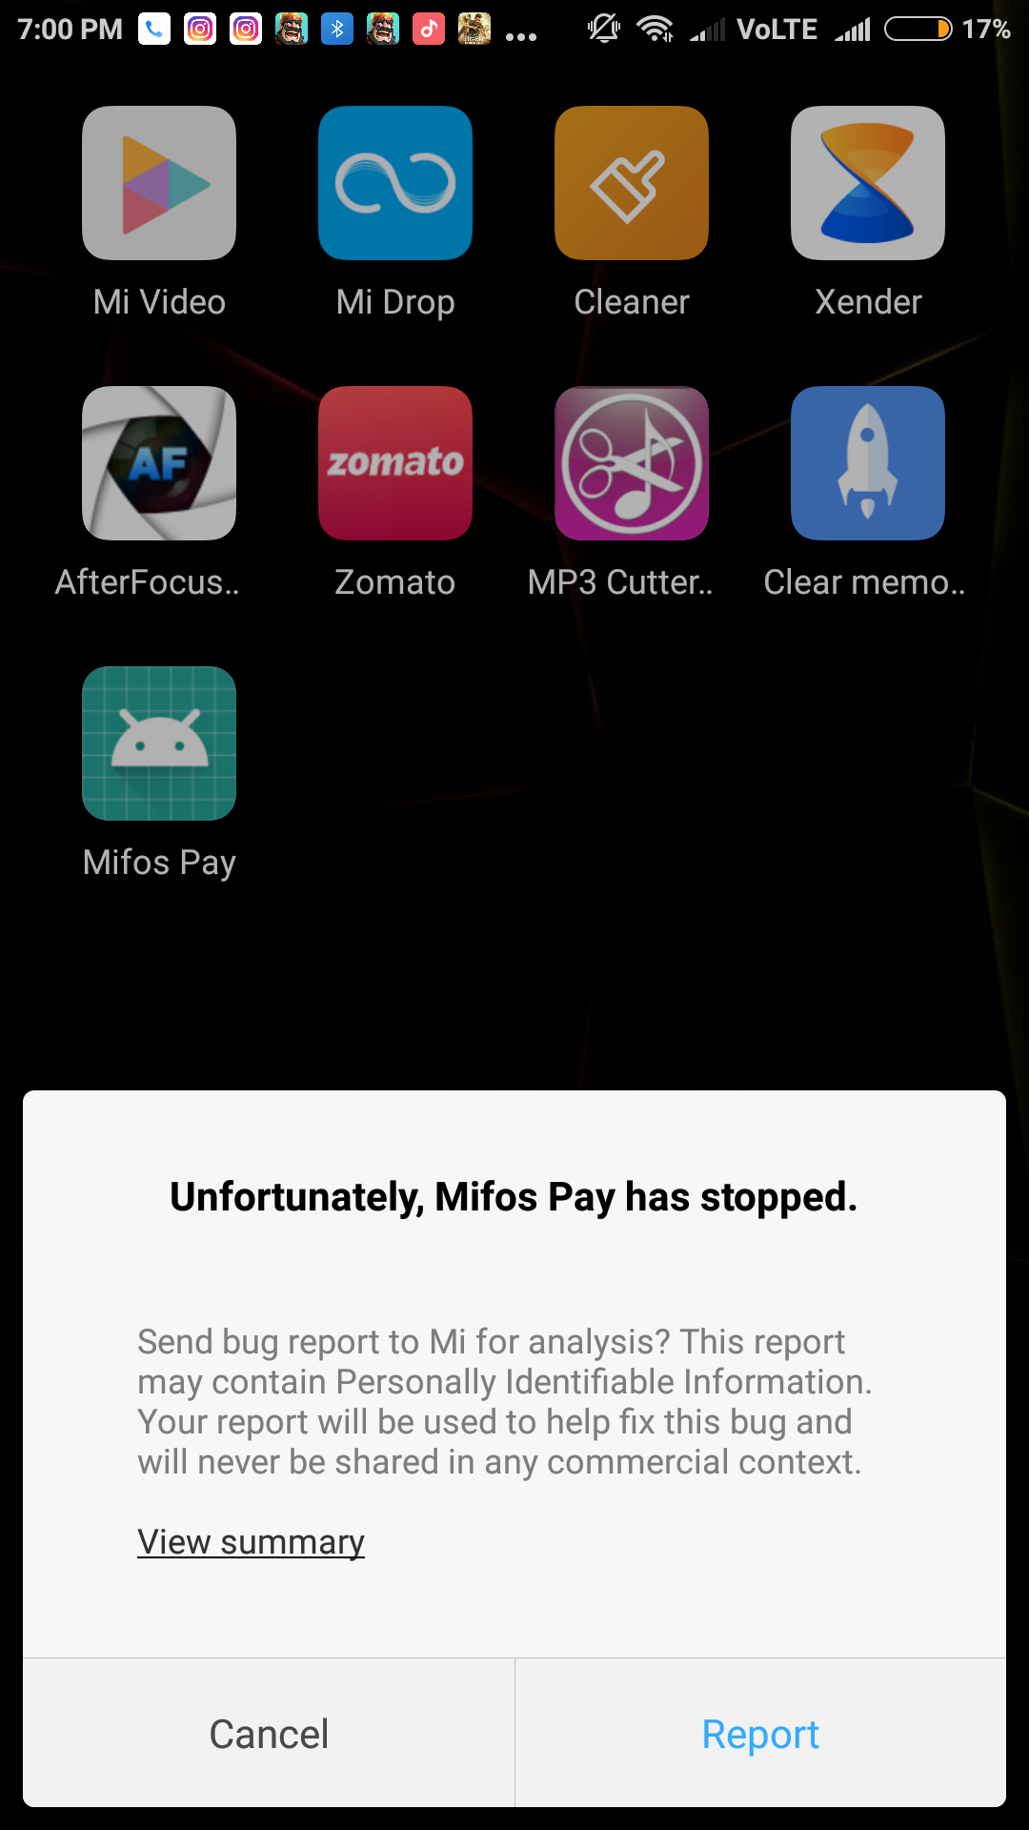
2) App wont let me register anywhere , nor a a merchant or as a customer. Appending a screen recording video.

Conclusion : The app wont let me past the Google Account verification page.

~Regards
Priyansh Gupta

